**EXECUTIVE SUMMARY**

**KEY BUSINESS QUESTIONS:**

How to maximize profit and revenue for the store, and do we have a loyal customer base?

**RECOMMENDATIONS:**

1. The client can ensure customers return to their store by incentivizing repeat visits, for example: introducing an offer where each coffee purchase earns customers 10 points and they can redeem a free coffee when they collect 100 points. This can be implemented until they become frequent visitors to the store.

2. Customers are much more likely to buy tea and non-caffeinated drinks in winter evenings. Client should introduce new and special tea, and non-caffeinated drinks and put them on the front of the menu to attract more customers since they are more likely to come across these products and purchase them. Posters of novelty items can be displayed outside the store to attract customers in. Pricing these new introductions at a slightly higher price could drive profits up since our customers purchase a lot of beverages and they are likely to try the new drinks.

3. Most of the coffee and food items are sold in the morning. Sales of them drop a lot in afternoon and evening, especially in the summer. Client should consider reallocating staff by the volumes of different time period and they should perhaps introduce happy hours in the afternoon to boost sales and promote customer loyalty. Happy hours will result in more customers coming to our store and this could lead to potential new customers. Also, the client should consider introducing new food items on the menu since the existing items on the menu are suitable only for breakfast and customers are not likely to have them in the afternoons and evenings.

4. During the summer months, the price for ice as ‘Extras’ has to be brought down or removed. By getting rid of the small additional price on ice, we can get more customers to buy our drinks which would generate more revenue in the long run.

5. Our client can get rid of beer from the menu since they do not get sold much and it increase our costs on inventory and storage as beer needs to be stored in cold storage to keep it chilled. They can be replaced with new creative ‘Summer Drinks’ or instead can just increase the inventory for the other existing items.

**ANALYSIS LEADING TO ABOVE RECOMMENDATIONS:**

Our first step is to explore the data by observing repeat visits by customers to gauge loyalty amongst customers. We further explore their contribution towards profits of the business. We observed that most of our profits are brought in by registered customers. However, most of our registered customers make only few transactions with us and they are not loyal to us in terms of duration and frequency. From these evidences we can conclude that our client's hypothesis that their customer base is loyal, is incorrect. Our client manages to get most of the visiting customers to register an account at the store, but they fail to turn them into loyal customers. The below graph illustrates the distribution of customers and their total transactions.

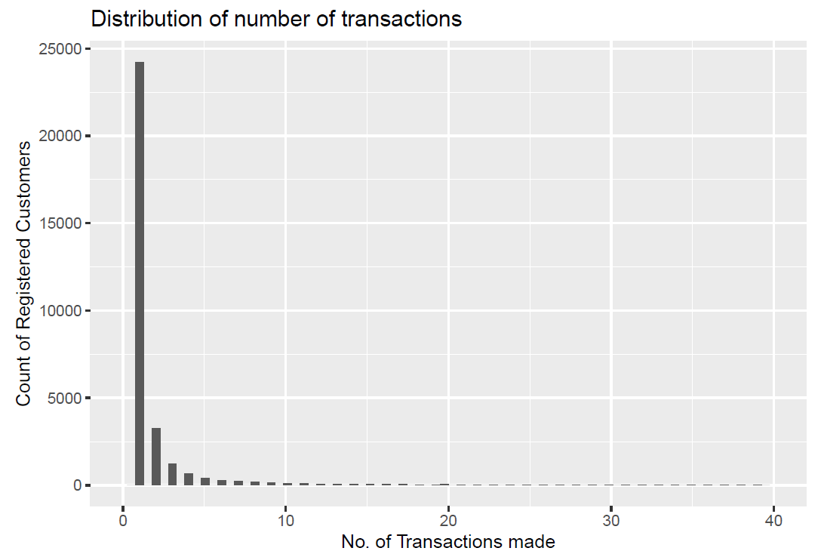

Most of the customers do not return to make purchases again. Even the customers who have made us good profit in the past, have stopped coming to our shop. We also see that buying products from category ‘Extras’ is an important characteristic of a loyal customer.

Next, we use association rules to understand sales by time element and customer type. This helps us in identifying correlations which can be exploited to increase sales and possible scenarios for low sales. Some of the important rules are:

1. Customers are much more likely to buy tea and non-caffeinated drinks in winter evening.

2. Most of the coffee and food are sold in the morning. Sales of them drop a lot in afternoon and evening, especially in the summer.

3. Registered customers like our food and non-registered customers are less likely to buy our food. This indicates that our food has good taste, but new customers do not purchase food items from the menu either due to lack of knowledge or lack of promotion of these items.

Apart from these rules, we notice that the additional cost of ice has driven customers away from purchasing drinks at our store. This price on ice has cost the client valuable purchases of caffeinated and non-caffeinated drinks.

Cautions:

We assume that the food taste is good because loyal customers have them regularly. We are not sure if the taste of food is what is driving away the new customers.